Practical 14.1.1
Aim:- Write a Python program using a class named Complex to add two complex numbers.
Algorithm:- Step 1: Start
Step 2: Define a class _{Complex}
Step 3: Define a method _{initComplex()}
- Input two integers (real and imaginary parts)
- Store them in self.real and self.imag
Step 4: Define a method _{sum(c1, c2)}
- Add real parts → self.real = c1.real + c2.real
- Add imaginary parts → self.imag = c1.imag + c2.imag
Step 5: Define a method _{display()}
- If imaginary part ≥ 0 → print real + imag i
- Else → print real - |imag| i
Step 6: Create three objects: _{c1}, _{c2}, _{c3}
Step 7: Call _{initComplex()} for _{c1} and _{c2} to take input
Step 8: Call _{sum(c1, c2)} using object _{c3}
Step 9: Call _{display()} using object _{c3}
Step 10: Stop

Flowchart:-
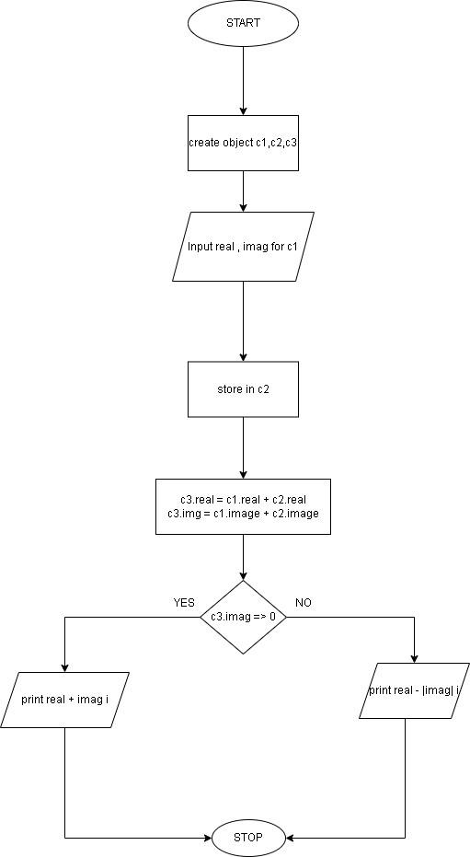
EXECUTION:
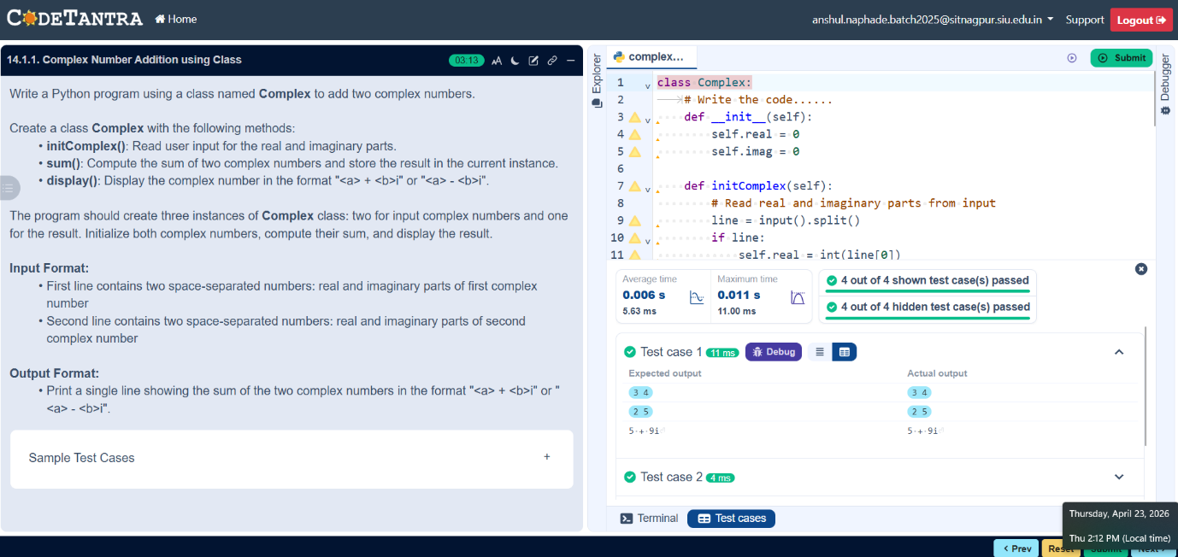

Practical 15.1.1
Aim:- Write a Python program to model a car dealership sales system using object-oriented programming. Create a base class Car and two derived classes Car1 and Car2 to represent different car types.
Algorithm:- Step 1: Start
Step 2: Define a base class _{Car}
- Initialize attributes: brand, price, model, color using constructor
Step 3: Define method display_details() in Car
- Print brand, price, model, and color
Step 4: Define subclass _{Car1} inheriting from _{Car}
- Override display_details() (prints same attributes)
Step 5: Define subclass _{Car2} inheriting from _{Car}
- Override display_details() (prints same attributes)
Step 6: Read input for first car
- Store brand1, price1, model1, color1
Step 7: Read input for second car
- Store brand2, price2, model2, color2
Step 8: Create object _{car1} of class _{Car1}
- Pass first car details to constructor
Step 9: Create object _{car2} of class _{Car2}
- Pass second car details to constructor
Step 10: Call display_details() for car1
- Display first car details
Step 11: Call display_details() for car2
- Display second car details
Step 12: Stop

Flowchart:
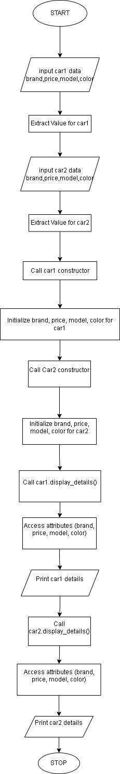

Execution:
